**AWS S3 Buckets**

* Amazon S3 (Simple Storage Service) is a cloud storage solution provided by AWS that lets users store and retrieve large amounts of data online. It’s designed to be scalable and reliable, used for tasks like backups, disaster recovery, and hosting static websites.
* Data is stored as objects in buckets, similar to files in folders. Each object has a unique key (identifier) and can be up to 5 terabytes in size. Buckets need globally unique names and are created in specific AWS regions.
* S3 offers various storage classes to optimize cost and access speed, including Standard for frequently accessed data and Glacier for long-term archival storage. Security is managed through IAM policies and encryption options.
* S3 also supports hosting static websites and provides tools like the AWS Snow Family for data transfer and edge computing, allowing data processing in remote areas. The AWS Storage Gateway connects on-premises data to S3 for hybrid cloud storage solutions.

**Create S3 Buckets Steps:**

1. Go to Amazon S3 Service and click on “Create Bucket” button.

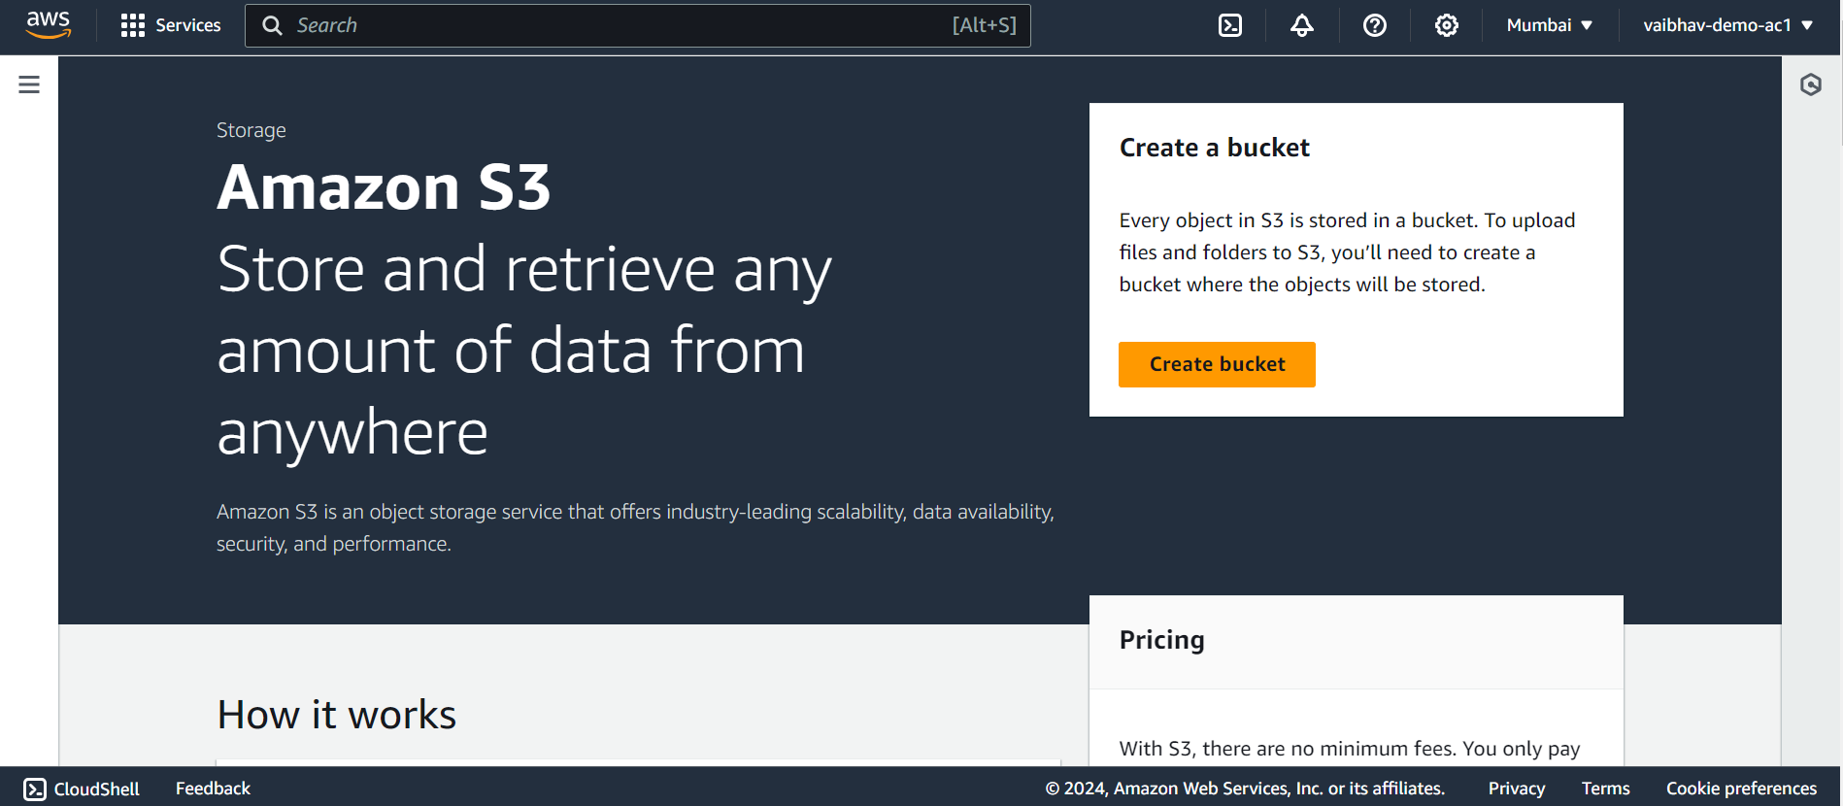

1. Enter Bucket-name and it is must be unique then select **Object Ownership** is ACLs disabled (recommended) and all other options are select as it is and click on “Create Bucket” button.

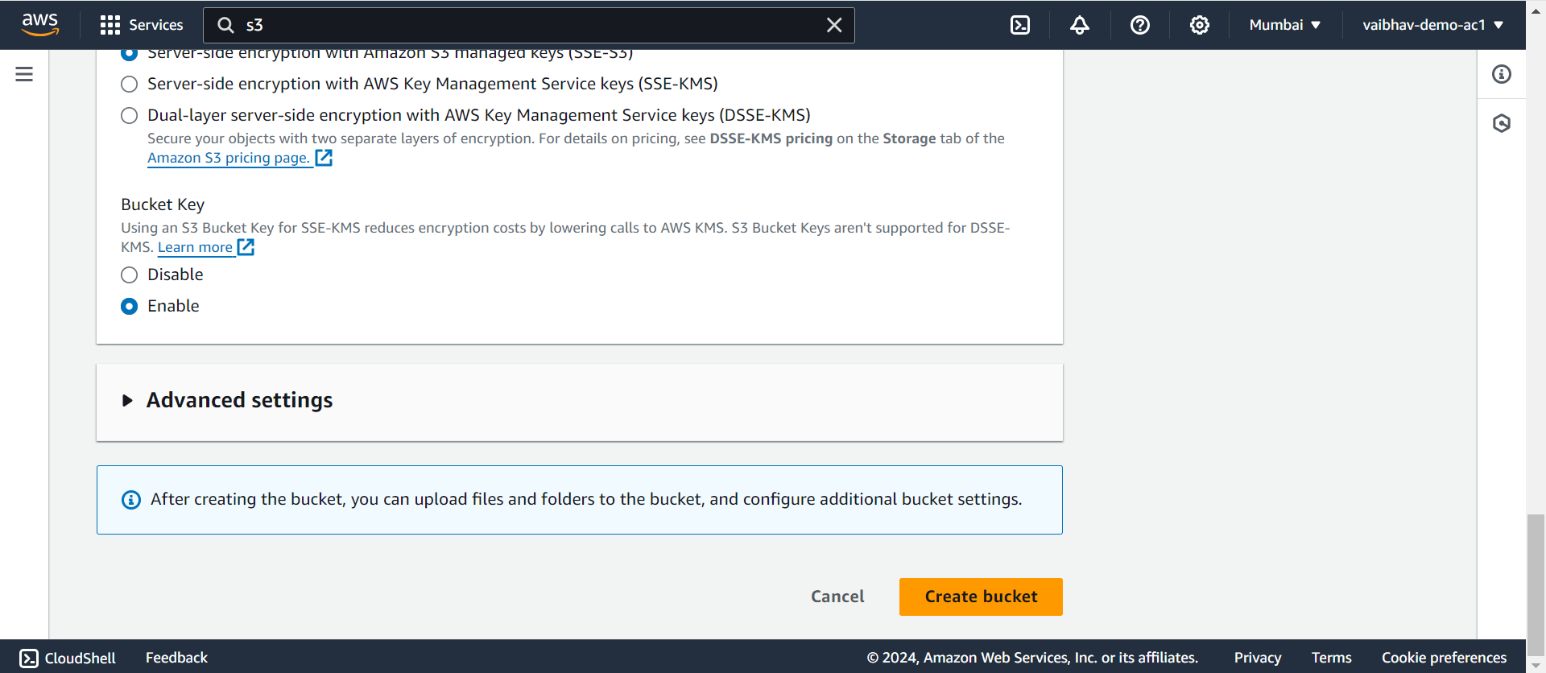

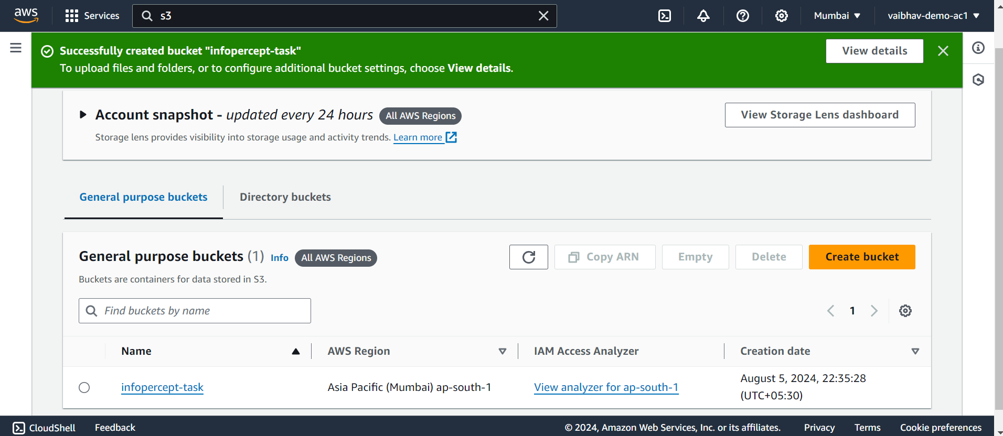

1. When we click on Bucket name then we can see the all uploaded objects.

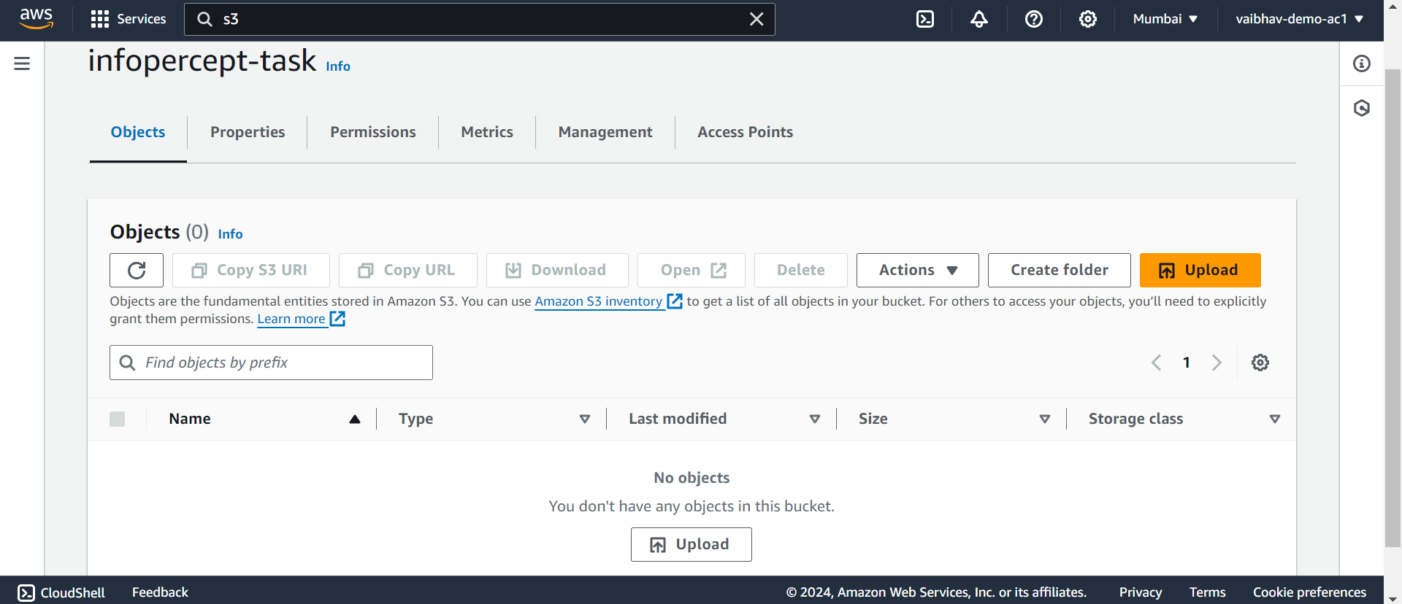

1. Upload objects – click on upload button and then click on Add files after select any files and click on upload button

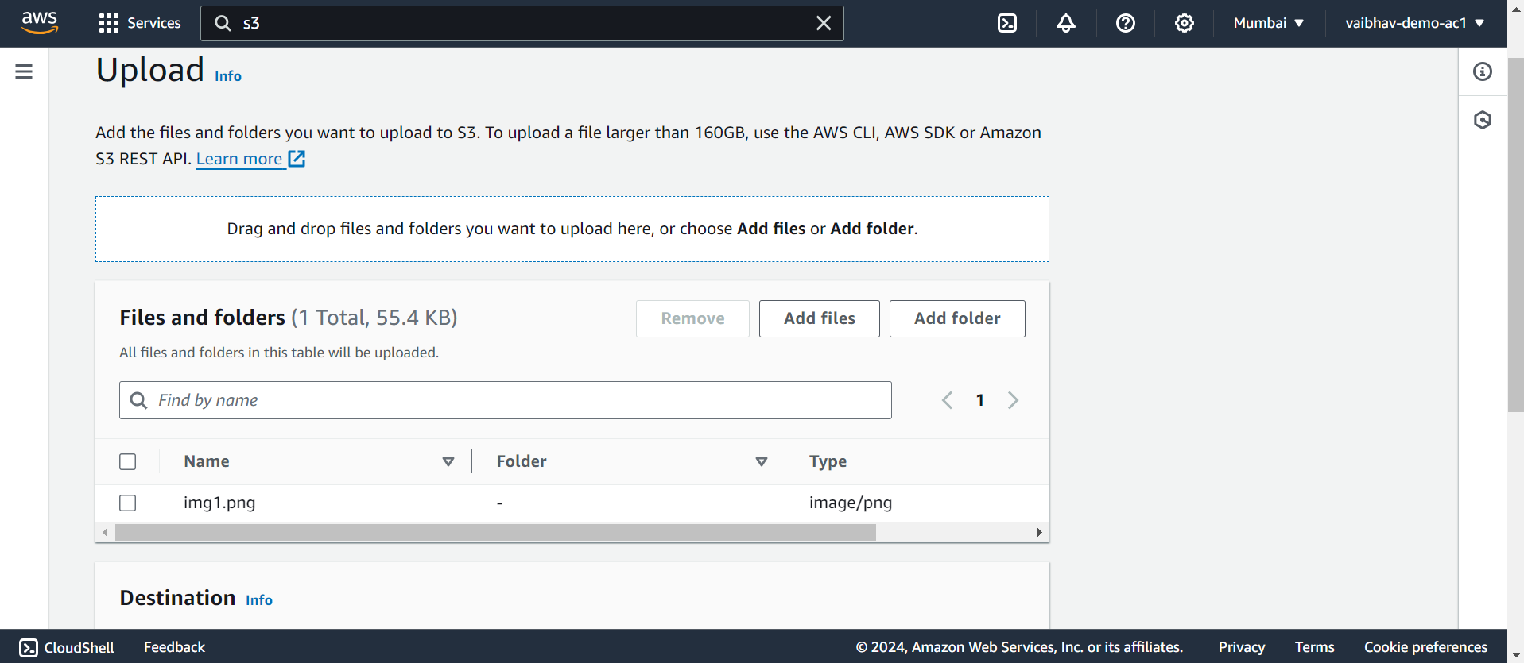

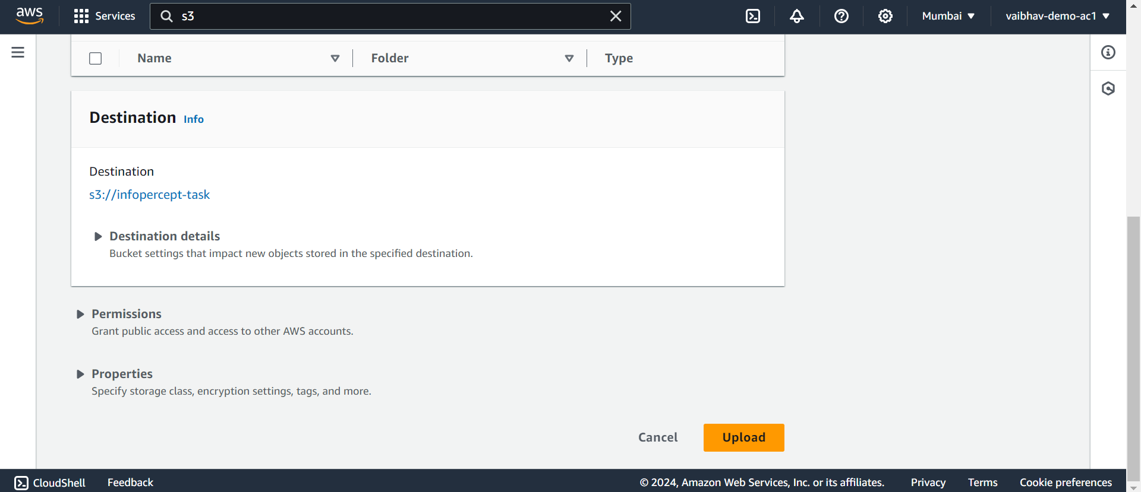

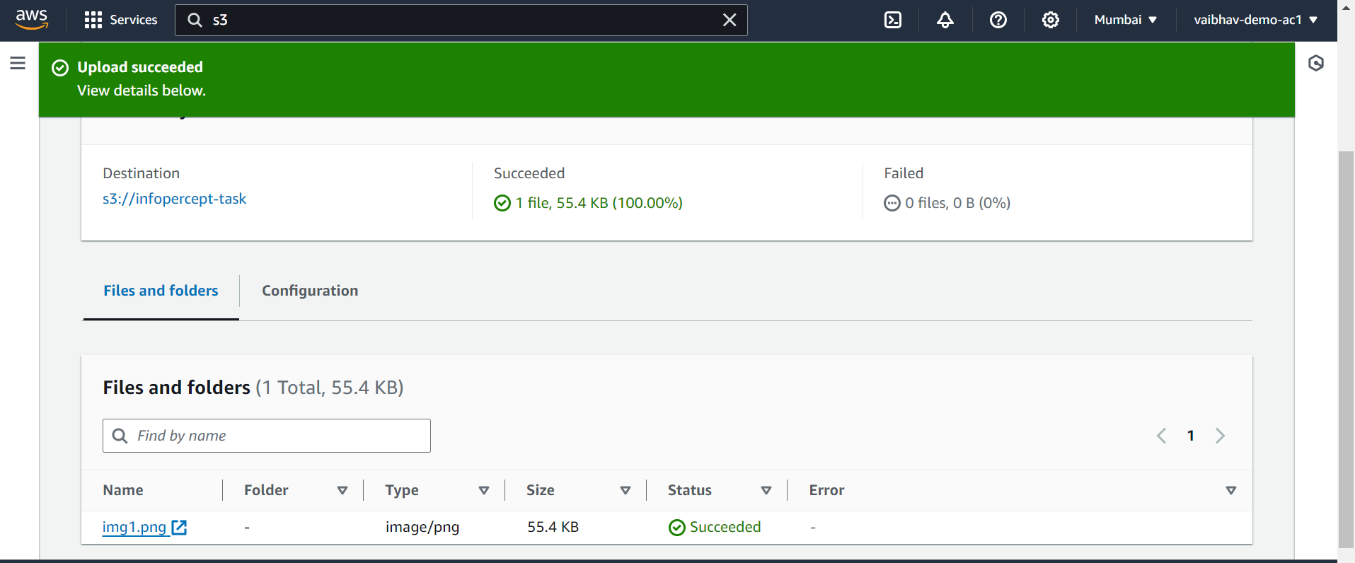

1. When we click on object name it show all properties of those objects.

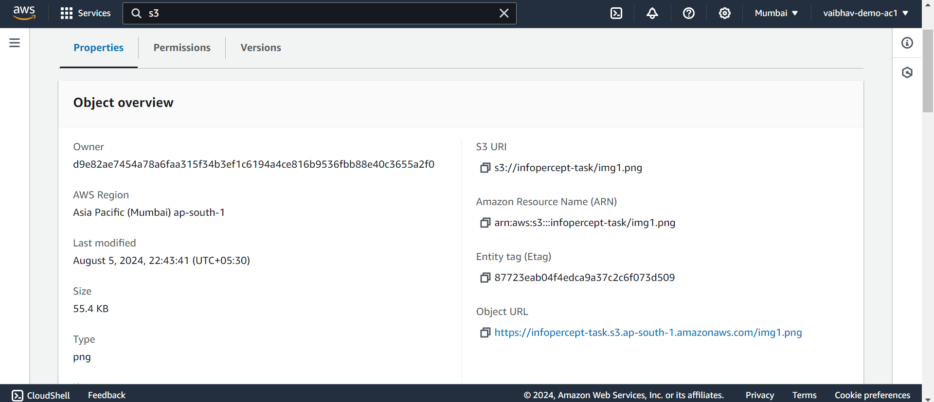

1. Click on “Open” Button to show objects like…

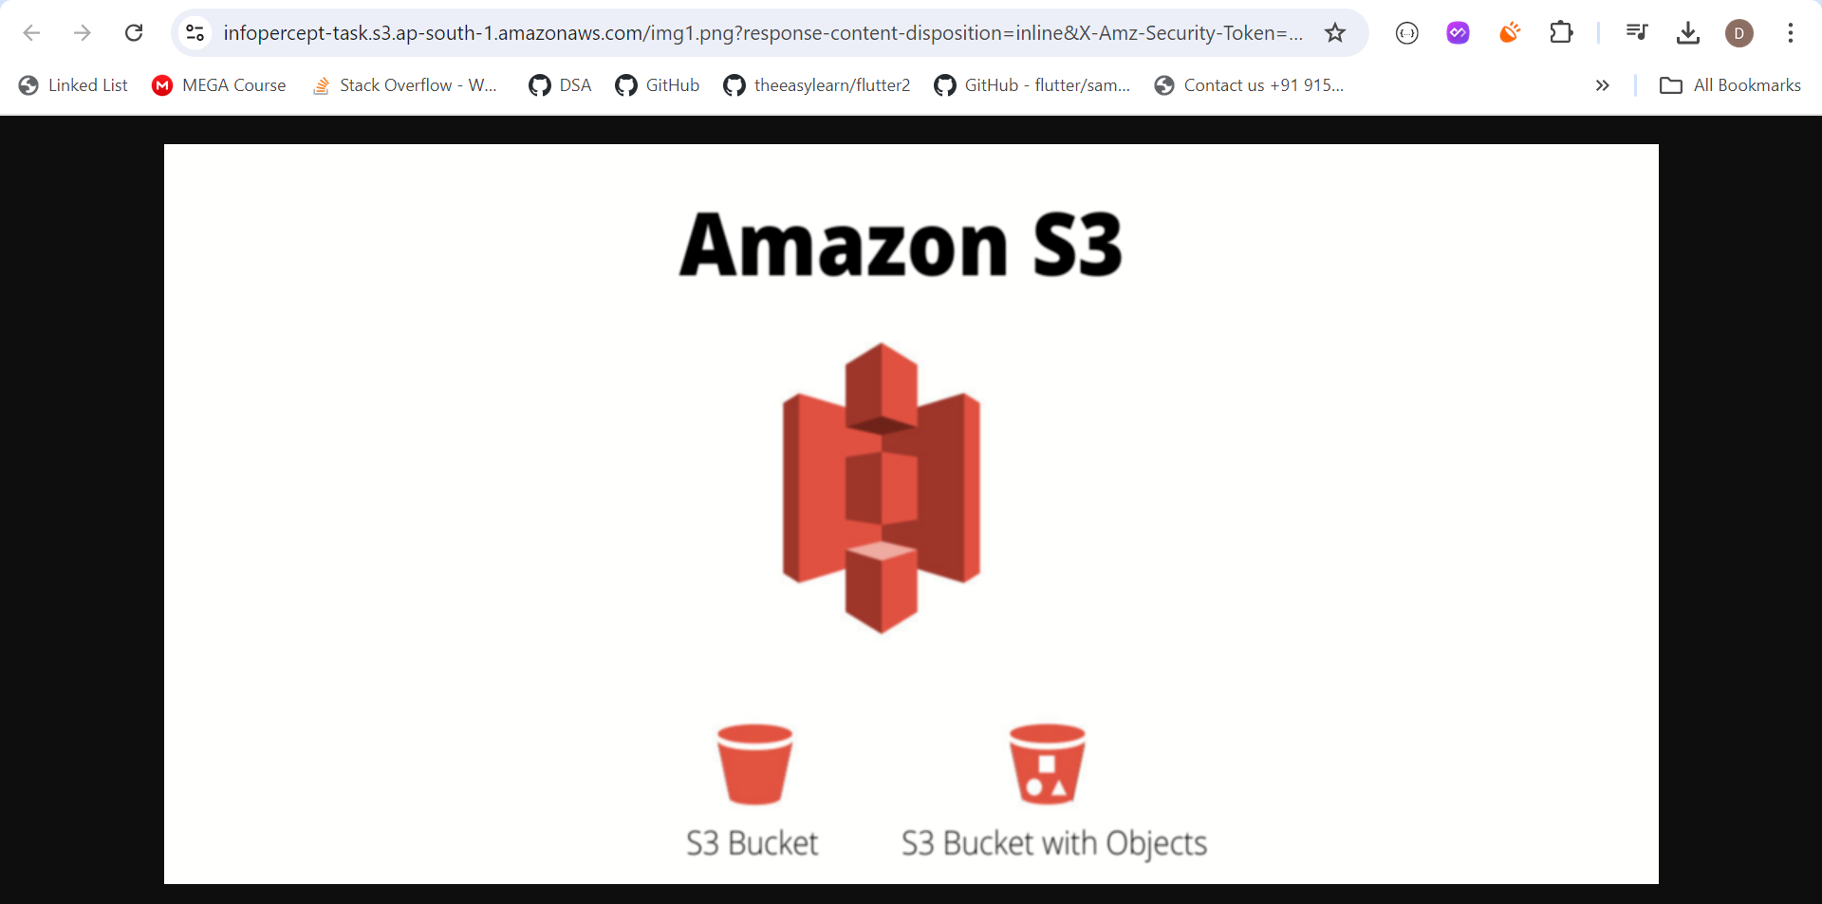

But when we click on object URLs it shows like..

